**How does Webpack Generate and Bundle Metronic (V.6.1.8) Scripts and CSS Files**

Webpack starts building project by following the instructions in webpack.config.js.

**Steps to Install npm or yarn Tools and Generate Metronic Bundle Files**:

1. Download and install Node.js from nodejs.org/en/download/ It’s better to download a zip file instead of a installer. After downloading NodeJs zip package, unzip it to somewhere.
2. The Path variable of environment variables may need a new entry to point to where Nodejs is installed.

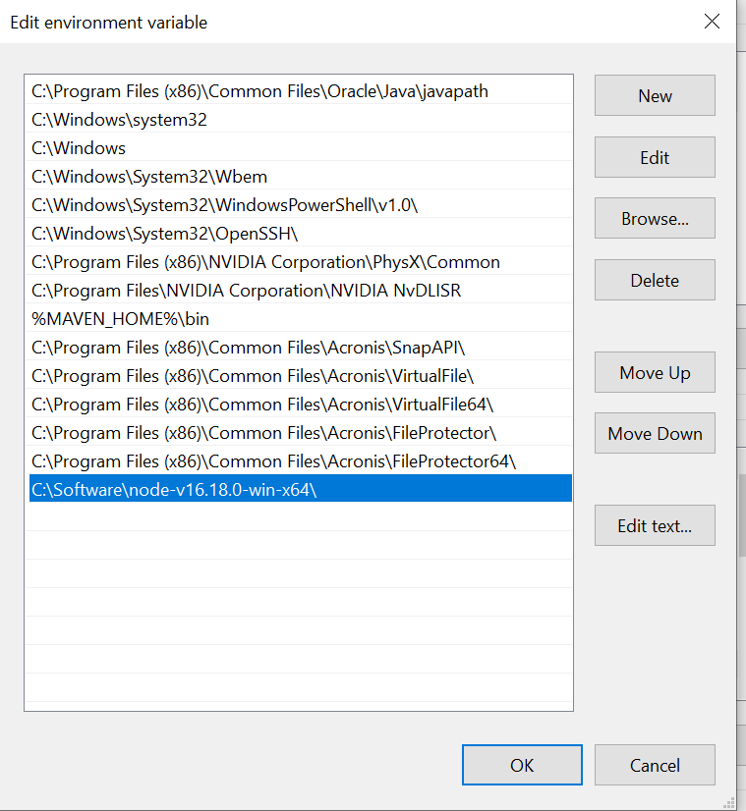

1. If the computer is in a corporate environment, strict ssl should be disabled to let npm download packages:

*npm config set strict-ssl false*

A .npmrc file under C:\Users\xxx will keep such value.

1. Install the correct version of npm. The latest version may have issues when invoking Webpack for building bundle files of Metronic v.6.1.8, so instead of

*npm install --global npm@latest*

Downgrade npm:

*npm install --global npm@6.14.5*

1. Install yarn via the npm

*npm install --global yarn*

1. Install yarn dependencies. Must execute in [metronic]/theme/default/[demo]/tools/ folder:

*cd theme/default/demo1/tools*

1. If the computer is in a corporate environment, strict ssl should be disabled before yarn can download packages. So do:

*yarn config set strict-ssl false*

A .yarnrc file under C:\Users\xxx will keep such value.

Then let yarn download all packages:

*yarn*

Sometimes Python 2 and MS libraries may be required in the system. If issues occur, try:

*npm install --global windows-build-tools*

Or:

*yarn global add windows-build-tools*

Sometimes, Python 2 need to be installed manually, so just let npm know where it is installed:

*npm config set python C:\Python27*

Files of windows-build-tools will be automatically downloaded under C:\Users\xxx\.windows-build-tools

1. Let Webpack compile all the assets (sass, js, media) and copy HTML templates to [metronic]/theme/default/dist/ folder:

*npm run build*

To generate minified scripts, do:

*npm run build --prod*

1. Start Webpack server in localhost (Optionally for quick test):

*npm run localhost*

**How Webpack Generates Bundle Files:**

There are 2 types of the JS codes: Custom and Bundlable.

The custom JS code is written in a JS file and minified and moved to the assets folder as a single file for each page or element that requires a certain level of customization, while the bundlable JS files are written in separate JS files that are also minified and added bundled into 1 main JS file.

The .js under [metronic]/theme/default/[demo]/tools/webpack folder is the JavaScript file for configuration, which specifies what JavaScript libraries and files need to be bundled.

It has @output in the comments, and webpack needs such information to create the final bundle file name and location.

What libraries need to be included or removed can be specified in those config .js files by adding or removing function “require()”, and we can let webpack to recompile them and produce new bundle files.

Instructions for general core scripts and css bundles are specified in scripts.js and styles.js.

The scripts.js directs Webpack to generate scripts.bundle:

*[metronic]/theme/default/[demo]/tools/webpack/scripts.js*

*===>*

*[metronic]/theme/default/[demo]/dist/assets/js/scripts.bundle.js*

The styles.js directs Webpack to generate style.bundle:

*[metronic]/theme/default/[demo]/tools/webpack/styles.js*

*===>*

*[metronic]/theme/default/[demo]/dist/assets/css/style.bundle (.js, .css)*

The global.js is the global vendor includes which required for all pages.

The global.js contains global mandatory plugins and optional plugins.

Plugin scripts and css bundles are specified in global.js.

The global.js directs Webpack to generate plugins.bundle:

*[metronic]/theme/default/[demo]/tools/webpack/vendors/global.js*

*===>*

*[metronic]/theme/default/[demo]/dist/assets/plugins/global/plugins.bundle (.js, .css)*

The JavaScripts under the custom folder direct Webpack to generate separate vendor’s bundles:

*[metronic]/theme/default/[demo]/tools/webpack/vendors/custom/[xxx].js*

*===>*

*[metronic]/theme/default/[demo]/dist/assets/plugins/custom/[xxx]/[xxx].bundle (.js, .css)*

**Optional Plugins in global.js**

Owl.Carousel

Touch enabled jQuery plugin that lets you create a beautiful responsive carousel slider.

<https://owlcarousel2.github.io/OwlCarousel2/>

require("owl.carousel/dist/assets/owl.carousel.css");

require("owl.carousel/dist/assets/owl.theme.default.css");

require("owl.carousel");

Daterangepicker

A JavaScript component for choosing date ranges, dates and times.

<http://www.daterangepicker.com/>

require("bootstrap-daterangepicker/daterangepicker.css");

require("bootstrap-daterangepicker");

Bootstrap-Select

The jQuery plugin that enables multiselection and searching

<https://developer.snapappointments.com/bootstrap-select/>

require("bootstrap-select/dist/css/bootstrap-select.css");

require("bootstrap-select");

Bootstrap-Session-Timeout

Session timeout and keep-alive control with a nice Bootstrap warning dialog.

<https://github.com/orangehill/bootstrap-session-timeout>

require("../../../src/assets/plugins/bootstrap-session-timeout/dist/bootstrap-session-timeout.js");

jQuery-Idletimer

Detect whether user is active or idle.

<https://thorst.github.io/jquery-idletimer/prod/demos/>

require("../../../src/assets/plugins/jquery-idletimer/idle-timer.js");

Bootstrap-Switch

Turn checkboxes and radio buttons into toggle switches.

<https://bttstrp.github.io/bootstrap-switch/>

require("bootstrap-switch/dist/css/bootstrap3/bootstrap-switch.css");

require("bootstrap-switch");

require("../../../src/assets/js/global/integration/plugins/bootstrap-switch.init.js");

Sweetalert2

A beautiful, responsive, customizable, accessible (WAI-ARIA) replacement for JavaScript's popup boxes.

<https://sweetalert2.github.io/>

require("sweetalert2/dist/sweetalert2.css");

import swal from "sweetalert2/dist/sweetalert2";

window.swal = swal;

require("es6-promise-polyfill/promise.min.js");

require("../../../src/assets/js/global/integration/plugins/sweetalert2.init");

Bootstrap-Notify

This is a simple plugin that turns standard Bootstrap alerts into "Growl-like" notifications.

<https://www.npmjs.com/package/bootstrap-notify>

require("bootstrap-notify");

require("../../../src/assets/js/global/integration/plugins/bootstrap-notify.init.js");

Bootstrap-Datepicker

Bootstrap-datepicker provides a flexible datepicker widget in the Bootstrap style.

<https://bootstrap-datepicker.readthedocs.io/en/latest/>

require("bootstrap-datepicker/dist/css/bootstrap-datepicker3.css");

require("bootstrap-datepicker");

require("bootstrap-datepicker/js/locales/bootstrap-datepicker.fr.js");

require("../../../src/assets/js/global/integration/plugins/bootstrap-datepicker.init");

Bootstrap-Datetimepicker

Date and time picker

require("bootstrap-datetime-picker/css/bootstrap-datetimepicker.css");

require("bootstrap-datetime-picker");

require("bootstrap-datetime-picker/js/locales/bootstrap-datetimepicker.fr.js");

Select2

Select2 gives you a customizable select box with support for searching, tagging, remote data sets, infinite scrolling, and many other highly used options.

<https://select2.org/>

require("select2/dist/css/select2.css");

require("select2");

Bootstrap-Timepicker

require("bootstrap-timepicker/css/bootstrap-timepicker.css");

require("bootstrap-timepicker");

require("../../../src/assets/js/global/integration/plugins/bootstrap-timepicker.init");

Tagify

Transforms an input field or a textarea into a Tags component, in an easy, customizable way, with great performance and small code footprint, exploded with features.

<https://github.com/yairEO/tagify>

require("@yaireo/tagify/dist/tagify.css");

window.Tagify = require("@yaireo/tagify/dist/tagify");

require("@yaireo/tagify/dist/tagify.polyfills.min");

Typeahead

A flexible JavaScript library that provides a strong foundation for building robust typeaheads (autocompletion).

<https://twitter.github.io/typeahead.js/>

window.Bloodhound = require("corejs-typeahead");

window.Handlebars = require("handlebars/dist/handlebars.js");

Dropzone

Dropzone.js is one of the most popular drag and drop JavaScript libraries. It is free, fully open source, and makes it easy for you to handle dropped files on your website.

<https://www.dropzone.dev/>

require("dropzone/dist/dropzone.css");

window.Dropzone = require("dropzone");

require("../../../src/assets/js/global/integration/plugins/dropzone.init");

ClipboardJS

Provide function for copying text to clipboard.

<https://clipboardjs.com/>

window.ClipboardJS = require("clipboard");

Autosize

A small, stand-alone script to automatically adjust textarea height.

<https://www.jacklmoore.com/autosize>

window.autosize = require("autosize");

Summernote

Super Simple WYSIWYG Editor on Bootstrap Summernote is a JavaScript library that helps you create WYSIWYG editors online.

<https://summernote.org>

require("summernote/dist/summernote.css");

require("summernote");

Quill

Quill is a free, open source WYSIWYG editor built for the modern web.

<https://quilljs.com>

require("quill/dist/quill.snow.css");

window.Quill = require("quill");

Inputmask

Inputmask is a javascript library that creates an input mask.

<https://github.com/RobinHerbots/Inputmask>

require("inputmask/dist/jquery.inputmask.bundle");

require("inputmask/dist/inputmask/inputmask.date.extensions");

require("inputmask/dist/inputmask/inputmask.numeric.extensions");

iOn-Rangeslider

A flexible and responsive range slider with skin support

<http://ionden.com/a/plugins/ion.rangeSlider/index.html>

require("ion-rangeslider/css/ion.rangeSlider.css");

require("ion-rangeslider");

jQuery.Repeater

require("jquery.repeater");

noUISlider

JavaScript Range Slider

<https://refreshless.com/nouislider>

require("nouislider/distribute/nouislider.css");

window.noUiSlider = require("nouislider");

Wnumb

JavaScript Number & Money formatting

<https://refreshless.com/wnumb>

window.wNumb = require("wnumb");

jQuery-Validation

This jQuery plugin makes simple clientside form validation easy, whilst still offering plenty of customization options.

<https://jqueryvalidation.org>

require("jquery-validation");

require("jquery-validation/dist/additional-methods.js");

require("../../../src/assets/js/global/integration/plugins/jquery-validation.init");

Bootstrap-Multiselectsplitter

Transforms a <select> containing one or more <optgroup> in two chained <select>.

<https://github.com/poolerMF/bootstrap-multiselectsplitter>

require("../../../src/assets/plugins/bootstrap-multiselectsplitter/bootstrap-multiselectsplitter.min.js");

Bootstrap-Maxlength

This plugin integrates by default with Twitter bootstrap using badges to display the maximum length of the field where the user is inserting text. This plugin uses the HTML5 attribute "maxlength" to work.

<https://github.com/mimo84/bootstrap-maxlength>

require("bootstrap-maxlength");

Bootstrap-Touchspin

Bootstrap TouchSpin is a mobile and touch friendly input spinner component for Bootstrap 3 & 4.

<https://github.com/istvan-ujjmeszaros/bootstrap-touchspin>

require("bootstrap-touchspin/dist/jquery.bootstrap-touchspin.css");

require("bootstrap-touchspin");

Bootstrap-Markdown

Markdown editor with Bootstrap

<https://github.com/refactory-id/bootstrap-markdown>

require("bootstrap-markdown/css/bootstrap-markdown.min.css");

require("bootstrap-markdown/js/bootstrap-markdown");

require("../../../src/assets/js/global/integration/plugins/bootstrap-markdown.init");

Animate.css

Animate.css is a library of ready-to-use, cross-browser animations for use in your web projects. Great for emphasis, home pages, sliders, and attention-guiding hints.

<https://animate.style>

require("animate.css/animate.css");

Dual-listbox

Dual Listbox is a pure JavaScript plugin that converts the normal select box into a searchable dual list box where the users are able to move options between two selection panels.

<https://github.com/maykinmedia/dual-listbox>

import DualListbox from "dual-listbox";

window.DualListbox = DualListbox;

require("dual-listbox/dist/dual-listbox.css");

Cropper.js

JavaScript image cropper

<https://fengyuanchen.github.io/cropperjs>

window.Cropper = require("cropperjs");

require("cropperjs/dist/cropper.css");

Font Icons

Font and Icons

<https://www.flaticon.com/free-icons/font>

require("../../../src/assets/plugins/line-awesome/css/line-awesome.css");

require("../../../src/assets/plugins/flaticon/flaticon.css");

require("../../../src/assets/plugins/flaticon2/flaticon.css");

require("@fortawesome/fontawesome-free/css/all.min.css");

require("socicon");